Jason Tan 9/18/21

**ESE 358 Project 2 Screenshots**

**COMPUTER ANIMATION Screenshot Outputs:**

**Augmented Reality Screenshot Outputs:**

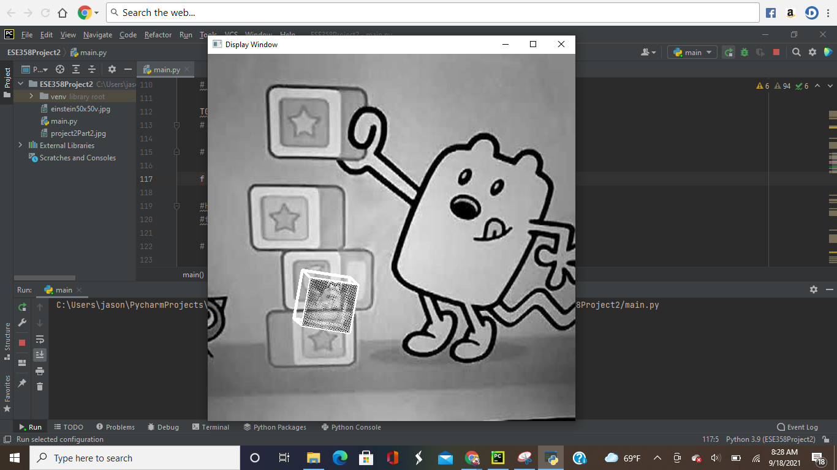

**FIgure 1:** Start of Output Sequence

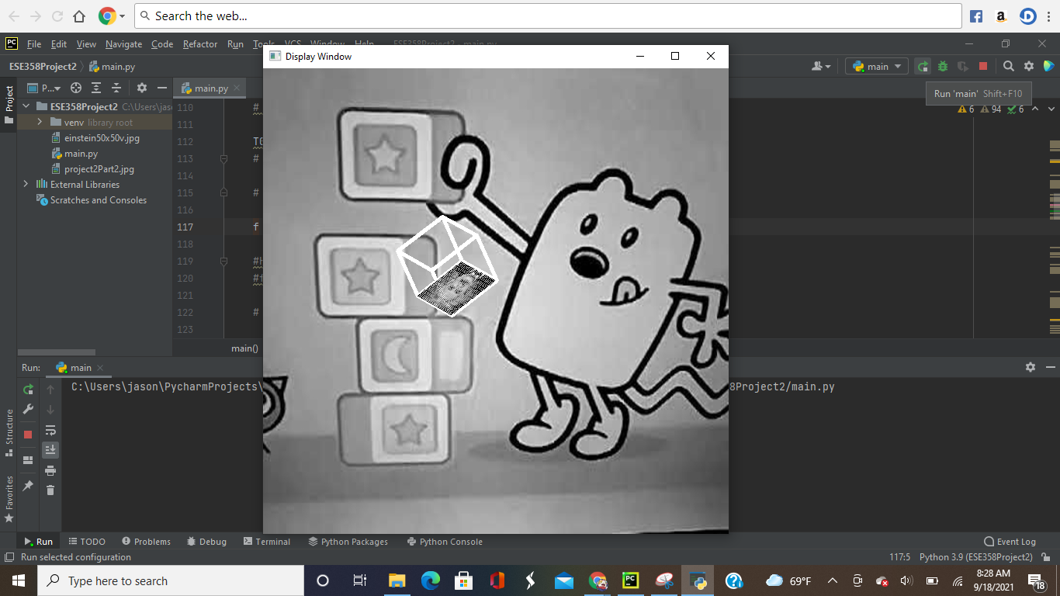

**FIgure 2:** In Between Output Sequence

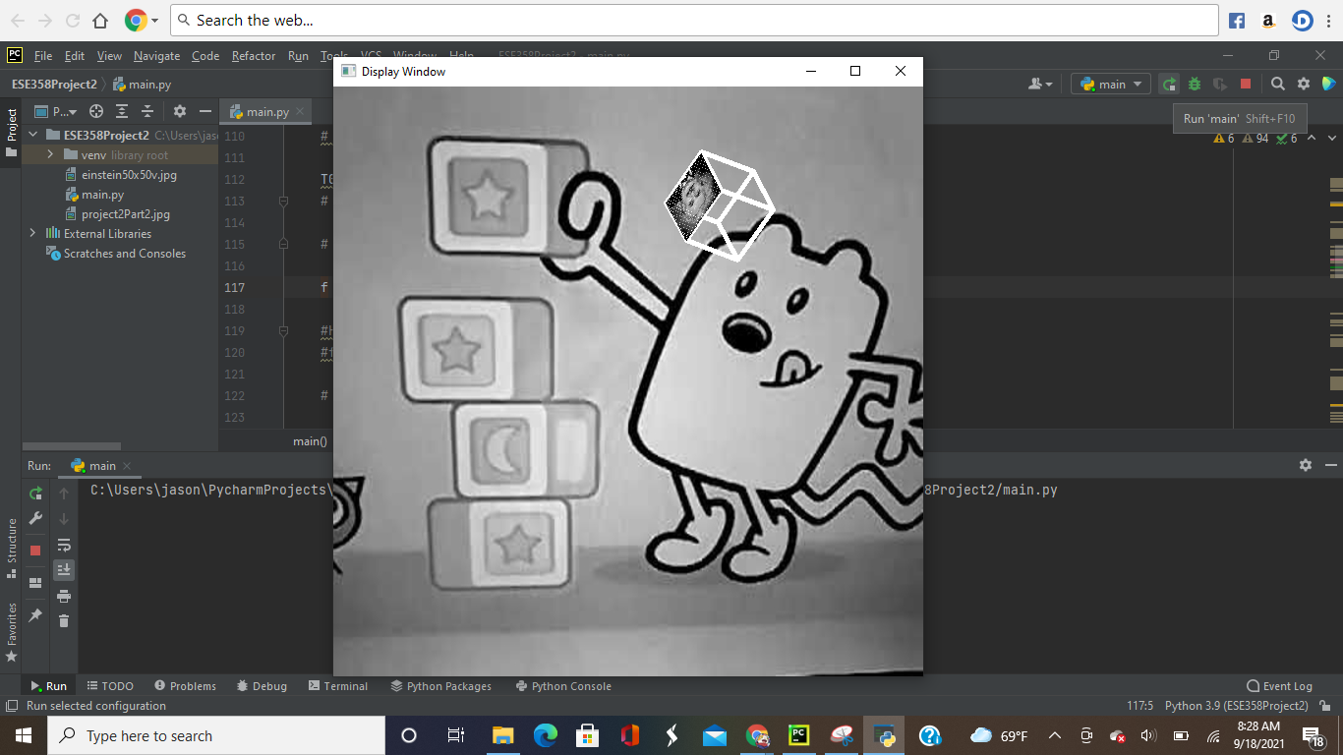

**FIgure 3:** Middle Output Sequence

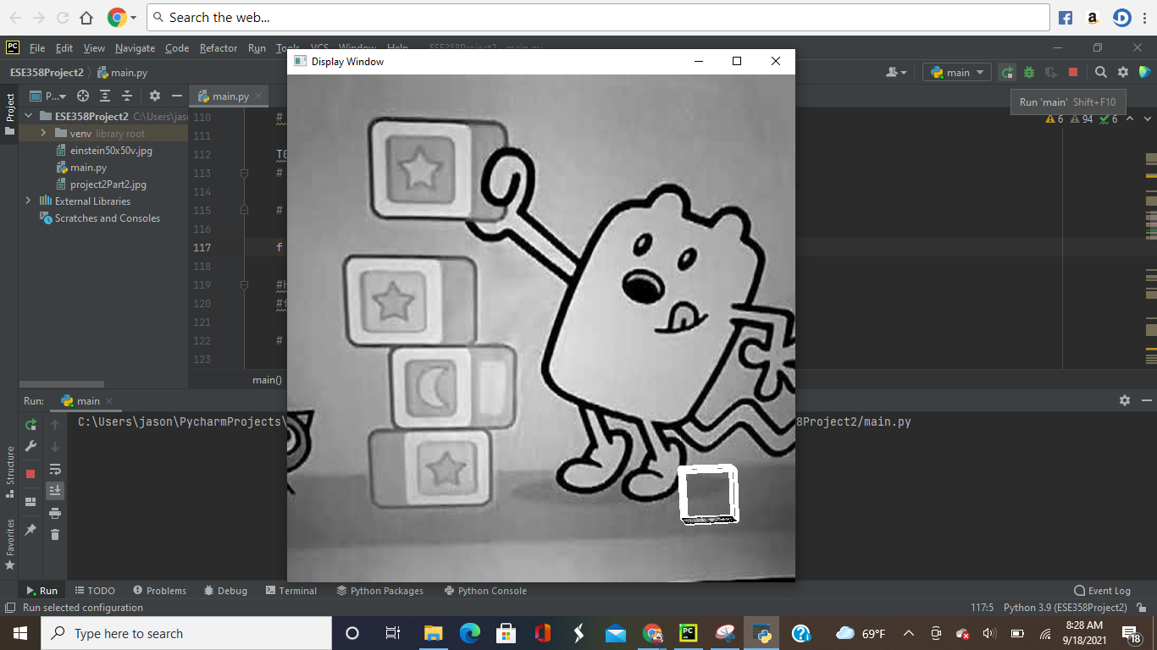

**FIgure 4:** End Output Sequence